Biometrics Assignment

Face Recognition System using the concept of Transfer Learning

Team Members

Arsh Mishra(RA1811030010039)

Divyansh Saxena(RA1811030010045)

Our mind knows about thousands of things and if some new object comes to our surroundings then our brain takes the input and train all the neurons for that particular object itself . It doesn't start from the beginning . So similarly we use pre-trained model to train it in such a way that is can identify the new object also. This concept is called as Transfer Learning.

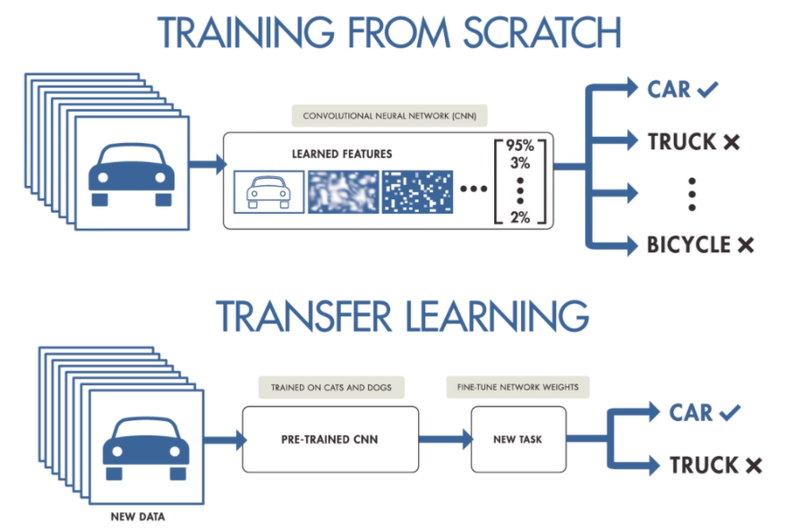

Here we used VGG16 as our pre-trained model. Below image will tell you about the architecture of VGG16 model.

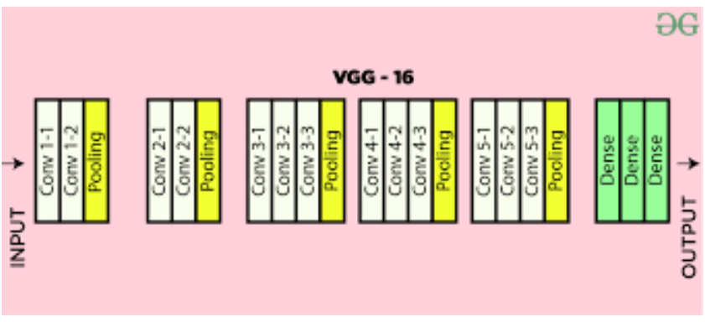

Here the dataset that i am using is divided into the partitions: training data and the testing data and after training the model by training data i will use testing data to predict it whether the model is predicting accurately or not.

Here I am using Adam optimiser to reach to the global minima while training out model. I am also specifying the learning rate of the optimiser, here in this case it is set at 0.001.

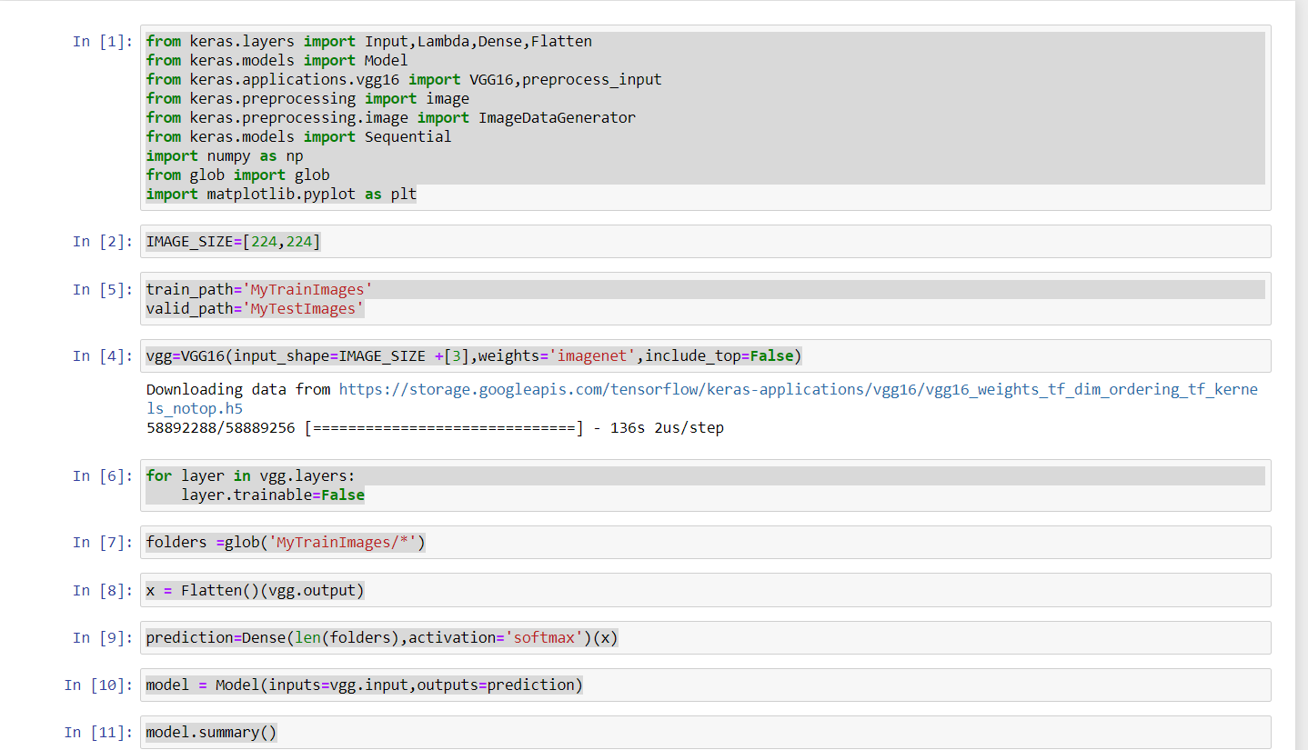

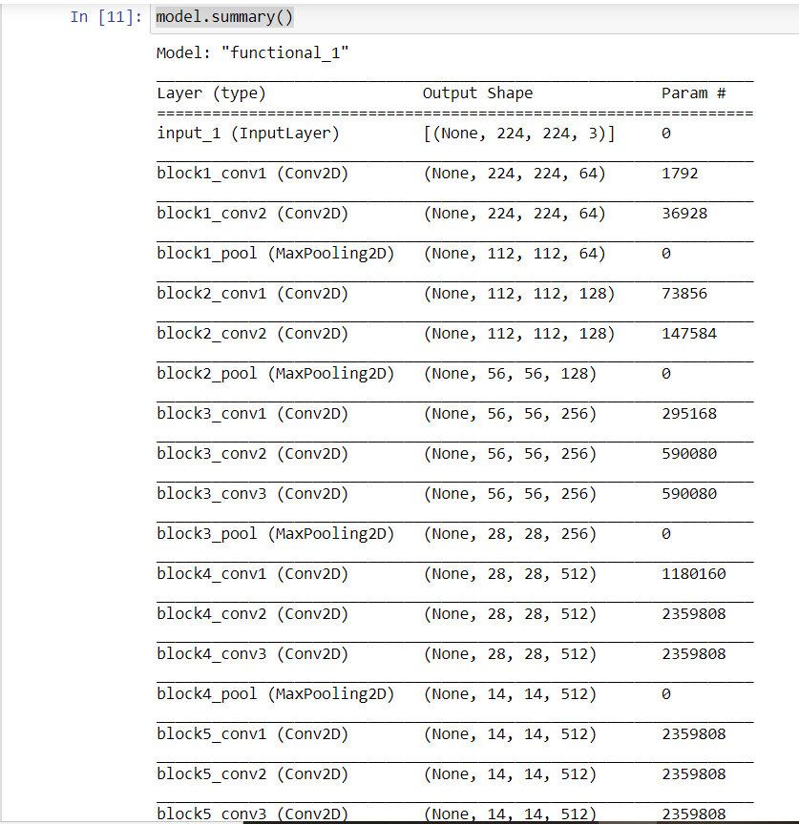

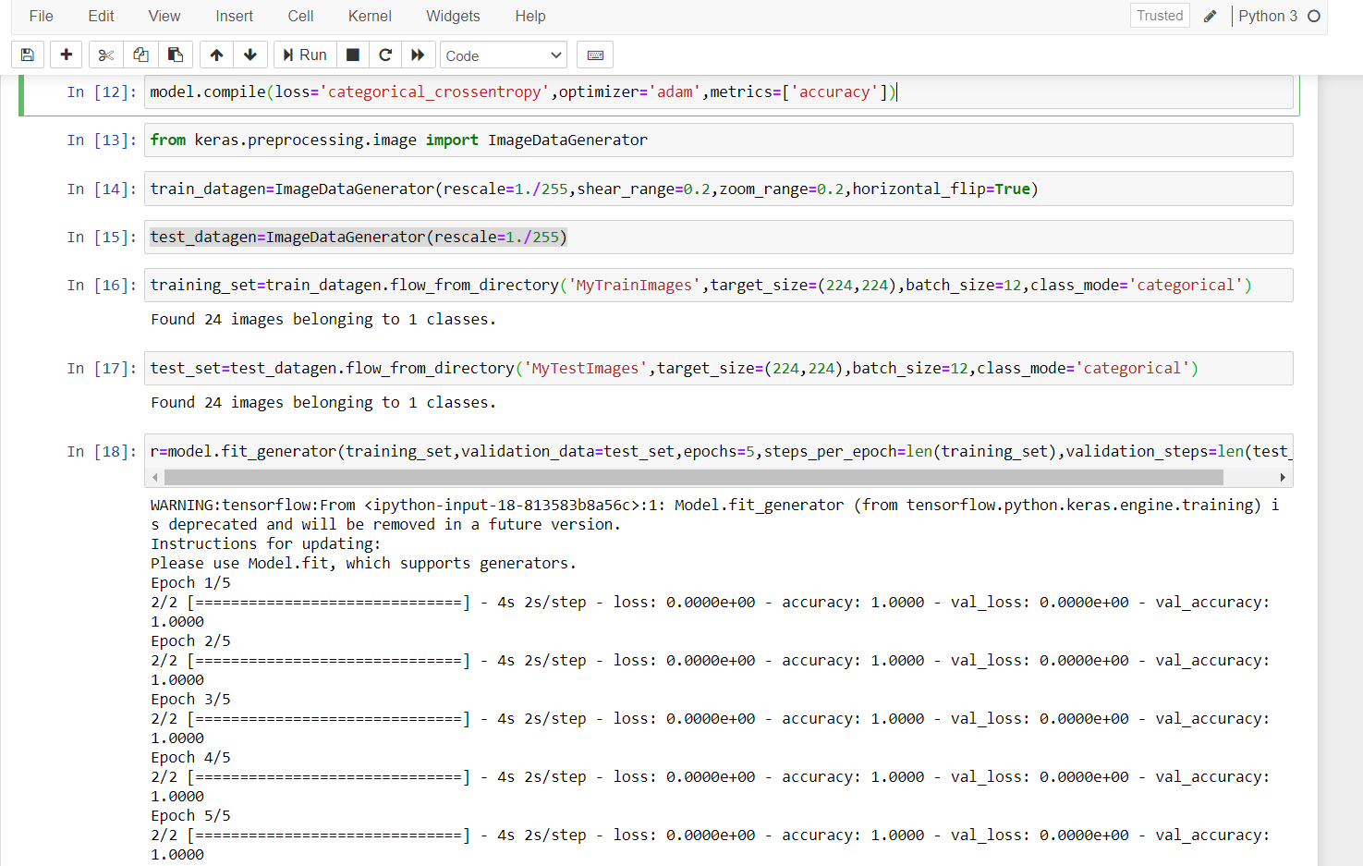

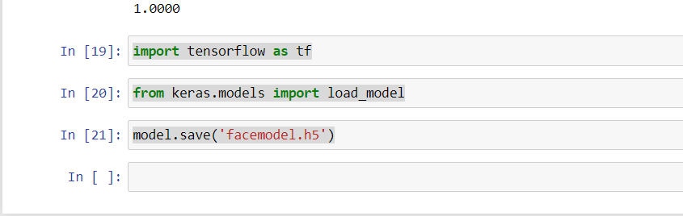

Code for deploying the model and checking the output

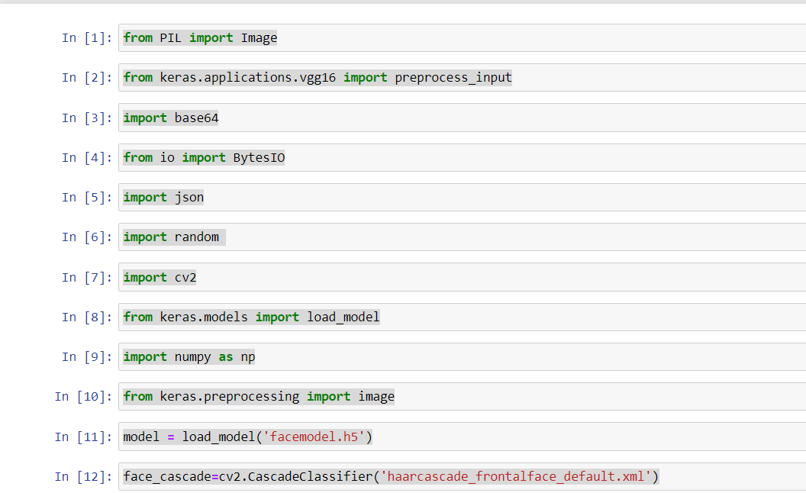

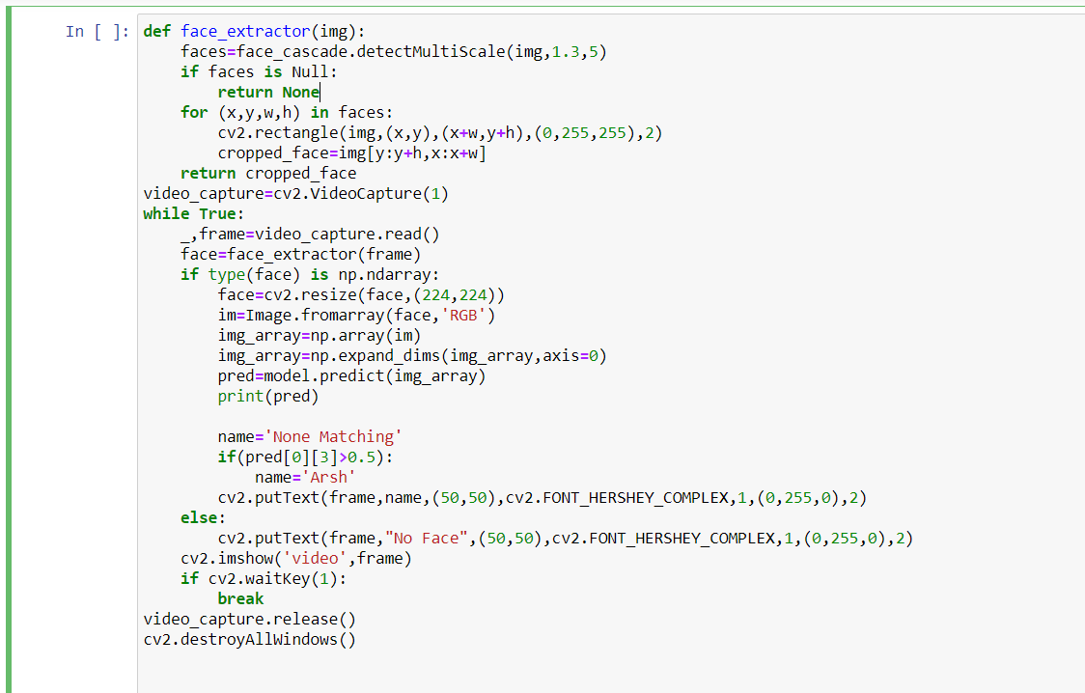

Output

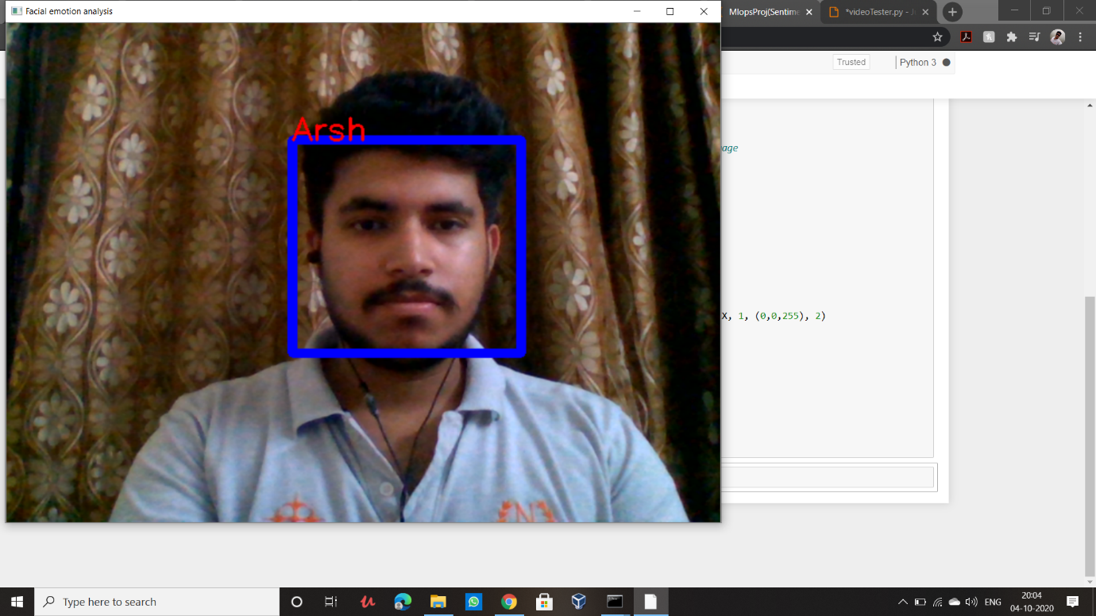

Thankyou